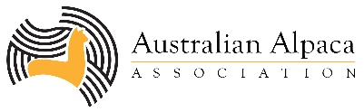**YOUTH COMPETITIONS**

**Gidgegannup Alpaca Show 2022**

Youth events will be held on Sunday 29 May at the Gidgegannup Small Farm Field Day.

Competitions are estimated to run from 9am-1.30pm. Exact start times will be available close to the event.

**ENTRIES CLOSE:** 1st May 2022 via eAlpaca

**ENTRY FEE FOR COMETITION $5 GATE ENTRY FEE** - FREE if pre entered ☺

|  |  |
| --- | --- |
| **SECTION: Junior Handlers** | |
| **CLASS Y1** | Novice 7-12 (<12 months experience with alpaca handling)  Available ages 7 to under 12. 1st Prize $25.00 |
| **CLASS Y2** | Novice 12-26 (<12 months experience with alpaca handling)  Available ages 12 to 26. 1st Prize $25.00 |
| **CLASS Y3** | Advanced (>12 months experience with alpaca handling)  Available ages 7-26. 1st Prize $25.00 |
| **SECTION: Junior Judging** | |
| **CLASS Y4** | Available ages 15-26. 1st Prize $25.00 |